**Force Transducer Repair**

Last updated by Unknown, but uploaded to the Wiki on 08 Apr 2015

Overview

An Aurora Scientific force transducer is currently used in most mechanical experiments the lab performs. This design consists of an internal glass "diving board" with metals bonded to both the underside of the board and the platform it is suspended above. The transducer registers force by changes in voltage that varies with the gap between the end of the glass diving board and platform. This is connected to the outside world by a capillary tube that is glued to the end of the diving board (like a person would stand on an actual diving board) and protrudes from a small hole in the force transducer cover.

This system is incredibly sensitive and also very delicate. There are many ways that it may be damaged, but the most likely is that the capillary tube gets either cracked or broken. This is a protocol on how to replace a broken capillary tube.

Additional resources

Need more help?

Check the resources, and then see Ken

Main content

**Materials**

* Vice
* Hex Keys and Small screwdrivers
* Small forceps
* Soldering iron
* Acetone
* A few different sized needles with a syringe to be used as a handle
* Razor blade
* Marine epoxy
* New capillary tubes
* Dremel tool with disc or file

**Part 1: Debris Removal**

1.  Remove the damaged force transducer from your setup and place capillary tube up in a vice

2. Carefully loosen then remove the six hex screws holding on the cover.  **DO NOT let the cover move sideways**; there may be remaining capillary tube going part or all the way through the hole.  Once all screws are removed lift the cover straight up and place aside.

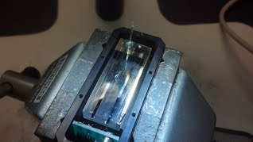

3.  Inspect the inside of the box for broken glass and the glass diving board for cracks.  If the diving board is cracked then it is not reparable and you are done.  If everything looks OK then carefully remove any loose pieces of the capillary tube and make sure there are no other obstructions.

4.  Check the function of the force transducer by plugging it back in then gently touch the diving board with something like the corner of a kimwipe.  If it alarms constantly or does not respond to light touches, it is most likely broken.  At this point you should get Ken for more expert diagnosis.

5.  If it appears to be working properly then you must remove the broken tube along with all the glue from the end of the diving board.  There are many ways this can be done, but remember the glass is most sensitive to forces perpendicular to the surface.  **Never try to pry glue upwards off of the glass**.  You may apply acetone with very small pieces of dampened kimwipe then scrape gently with needles/pieces of razor blade.  You may also use heat to soften the glue.  This can also be varied to find what works best for you. Just work gently until the capillary tube and all of the glue has been removed.

Ben's favorite method is to connect a ~26ga needle to the syringe then place the tip of the soldering iron about halfway down the needle.  Keeping the two together, push the needle tip along the edges of the glue.  It should work sort of like a snow plow peeling off small strips at a time.  Work slowly from each side until all of the glue is removed and the capillary tube can be removed.  You may need to clean off a little bit of glue with the razor blade.

Charles' favorite method is to get a flat blade (exacto or tip of a razor blade) and get it as hot as possible (using a soldering iron or flame source).  The blade can then be used to slowly scrape up the epoxy like a paint scraper.  But the blade must be very hot for this to work effectively.

When using heat, also be cautious not to get really hot sources (flames) near the diving board; you don't want to melt the metal film!

You should now have a clean diving board.

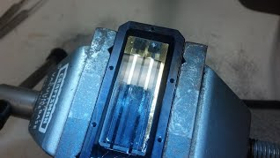

**Part 2: Placing the New Tube**

1. You will need to make a new tube out of "Sutter Instrument" capillary tubes, with a outer diameter of 1.0 mm and inner diameter of 0.50 mm. Break a few pieces about 1.5 cm each. You can use the file to smooth out the rough edge.

2. Gather the marine epoxy, weigh boat, needles, glass slides, transducer cover with screws, and new tubes. Place the force transducer under the dissecting scope and secure it with something like stacks of business cards or glass slides. Make sure there is no debris left inside the force transducer and the diving board is clean.

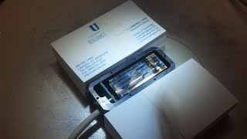

Steps 3-7 should be done relatively quickly, read through them and have a plan before beginning

3. Mix equal parts of the epoxy in the weigh boat. Use a needle to place a small amount on the center of the diving board, below where you think the hole will be.

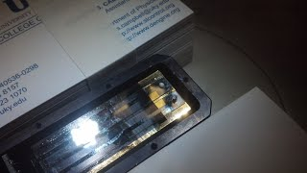

4. Replace the cover and look through the hole to make sure the epoxy is directly underneath

5. Carefully pick up a new tube with forceps and apply a very small amount of epoxy into one end, making sure its not larger than the diameter of the capillary- you don't want to get any on the cover or hole!

6. Insert the tube, epoxied end first, through the hole and into the drop of glue on the diving board. Be very careful not to get glue on the edges of the hole. (If you see glue on the edge of the hole, or connecting the hole and the capillary tube, remove it immediately and clean out the glue. You do NOT want your tube attached to the cover!)

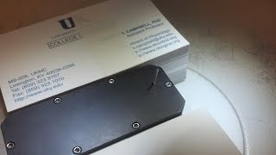

7. Use 3-4 glass slides to align the tube vertically in the center of the hole.

